MORRISTOWN RECREATION
SUMMER CAMP
PARENT HANDBOOK
2024
Town of Morristown
P.O. Box 748
43 Portland St.
Morrisville, VT 05661
tel:1-802-888-6378
http://www.morristownvt.org/rec
Recreation@morristownvt.gov

Thank you for choosing Morristown Recreation Summer Camp 2024! We are so excited about this year!

The summer camp program runs for seven weeks in the summer and offers a fun and safe program to promote healthy living, eating, and exercise with a variety of planned activities for children ages 6 through 12. Our vision is to provide a safe environment where all children will experience community, expand their learning, and creativity, create everlasting friendships, and engage in recreational activities to deepen their appreciation of Vermont’s beautiful landscape and focus on core values:
•Safety: We provide a safe, healthy, and welcoming environment for everyone involved in the Morristown Summer Recreation Program. Every effort is made to help each member of the community be physically, psychologically, and emotionally safe.
•Respect: We work to develop and foster respect, care, and concern for ourselves, others, and property used to create a fun camp experience. Treating people with dignity means treating them the way we’d like to be treated ourselves. Every human has the right to be respected for who they are, what they believe in, and how they live. Concerning our race, gender, age, and economic status; we all share the right to live a life full of dignity and be treated with respect.
•Responsibility: We encourage responsibility for actions, words, and choices. This involves making decisions, being trusted, and taking credit for behavior, whether good or bad. Our goal is to foster campers becoming positive citizens through every interaction and experience they have.
•Belonging: We thrive when we have a sense of trust and security. We accept and are respectful of all people. Our goal is to get to know each member of our program, find out ways to showcase how much they matter, and make sure they know they are welcome.
•Community: We come together and commit to creating a space that protects the health and safety of all community members. We strive to create an environment that supports everyone’s needs for play, activity, sensory stimulation, fresh air, rest and nourishment.
We focus on value themes for each week, and we invite you as families and community members to help support our program in partnering with these themes.
Week 1-Safety & Belonging
Week 2-Respect & Responsibility
Week 3-Gratitude & Teamwork
Week 4-Friendship & Creativity
Week 5- Compassion & Integrity
Week 6-Honesty & Perseverance
Week 7-Dignity & Worth

WHAT TO BRING
Please label all personal items and clothing with your child’s name with permanent ink or labels. The Morristown Recreation Department is not responsible for lost, misplaced, or stolen items.
All Shoes must be close-toed and close-heeled that stay securely on the feet.
- Water shoes can be worn at the river, but they must be secure on the foot, and they cannot be worn for daily activities. Flip-flops are not considered water shoes.
Bring a backpack with the following items

Morning and afternoon snacks Swimsuit & Towel

Water bottle Rainwear

Lunch* Sunscreen & insect repellant

Extra set of clothing Hat & Sunglasses

Swimming Bracelet*
*Breakfast and lunch are available free from the school this year. A monthly menu will be sent out, and campers can choose to sign up daily if desired. If your child is not eating school lunch, please pack them one.
* Child will receive a swimming bracelet their first-time entering camp. This corresponds with the swimming level stated on their registration. Child needs to come wearing this every day they attend camp.
Parents will be required to grant a yes or no permission for Morristown Recreation staff to apply sunscreen/insect repellent to their children.
WHAT *NOT* TO BRING
We try our best to provide a fun and distraction-free environment, please refrain from bringing the following items to camp. Cell phones are NOT allowed at camp. If staff sees a child with a phone it will be taken and returned to parents at the end of the day.
Electronics (i.e., cell phones, games, tablets, etc.)
Toys
Money
CHECK-IN/CHECK-OUT PROCEDURES
Please read the following carefully so you have a clear understanding of our check-in and check-out processes. Drop off and pick up will occur in front of the gymnasium at People’s Academy. We ask that park in the parking lot and walk your child into the gymnasium lobby. PLEASE DO NOT PARK IN THE BUS LANE (closest to the gymnasium) during either drop-off or pick-up. Buses are entering and leaving the school daily, and the safety of students is our priority. You must have contact with the camp staff member who is at check-in to alert them that you are dropping off or picking them up, and physically sign them in on our sign-in sheet. For pick-up, the camp staff member will radio the counselors to alert them and bring your child out to you. Parents must check their children in before sending children to their teams.

Check-in is from 7:30 am-8:30 am. If you arrive after the drop-off time, please be aware that your child’s group has already started their day and may have left already for a field trip.
Check-out is from 3:30 pm-4:30 pm sharp. If you are late for pick-up, you will be charged a late fee of $10 per occurrence. This payment must be settled prior to your child’s next scheduled day to attend camp. Failure to pay will result in termination from the program. We do NOT offer an early drop-off. This time is for our staff to prepare for the day. Please respect this time.

APPOINTMENTS/EARLY PICK-UP
Late arrivals and early pick-ups are highly discouraged during the camp day. Due to the “on-the-go” format of our camp, campers could be on campus, at the nature trail, around the town, or on a field trip. It becomes very difficult for our staff to try and coordinate a child being picked up early.
If an early pick-up is unavoidable, you must provide the Camp director with a written note at the time of check-in. If a last-minute early pick-up is necessary and you were unable to inform the Camp Director in the morning, please call the Recreation Coordinator as soon as possible at 802-888-6378. Please plan for extra time when picking up your child.

LATE PICK-UP PROCEDURE
The Morristown Recreation Department works diligently to provide affordable programs to the community, The affordability of our programs greatly depends on o the promptness of the parent pickup. Please pay close attention to the end time and pick-up location of your child’s program. Parents who picked up after 4:30 pm will be charged an additional $10 per occurrence.
Fees will be invoiced at the time of pickup or within 24 hours and must be paid prior to future involvement or enrollment in programs. Exceptions may be made if staff is contacted in advance for extenuating circumstances on a case-to-case basis.

PAYMENTS
Payment in full is due prior to attendance. If attending weekly payment is due by the Sunday preceding the camp week. If payment has not been made, the child may not attend camp. To receive the discount entire summer rate, payment must be made in full by June 25th. After June 25th the weekly rate applies.
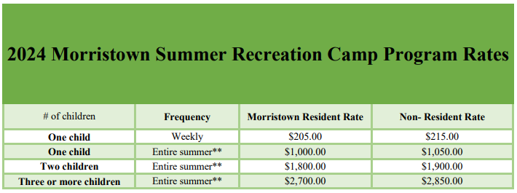
REFUND POLICY
If a participant cancels out of the program, refunds will be handled as stated below. If you have an outstanding balance, the refund will be automatically applied to that balance and any remainder will be refunded. Refund checks take approximately three weeks to process.
- Processing Fee: $10.00 is deducted from all refunds except canceled programs. The remaining is refunded as stated.
- Remaining Balance: Will be refunded up to one (1) week prior to the start of the program.
- A 50% refund will be made if cancelation is made before the first two weeks of camp.
- No Refund: After the third week of camp no refund will be issued.
If unforeseen circumstances arise due to the child’s health or injury, refunds will be prorated and handled on a case-by-case basis.

AUTHORIZATION FOR PICK-UP
Parents/guardians are asked to provide a list of people authorized to pick up their child at the time of registration. We will not release your child to anyone who is not on the list. If you need to update the list, you can do so at check-in or check-out by clearly communicating with the Camp Director. If this is a last-minute situation, you must notify the Recreation Coordinator at 802-888-6378.

TRANSPORTATION
Parents/guardians must transport their child to and from camp each day. Any transportation for activities and field trips is provided.

WALKERS OR BIKERS
Any child with permission from a parent/guardian to walk or ride a bike to and from our camp must provide the Camp Director with a written note. The time f arrival and departure must be clearly stated on the note. Participants who ride their bikes to camp shall not ride nor play with their bikes during the program hours unless it is a specified bike day.
SWIMMING AT CAMP
During registration, each parent is asked to list their child’s swim level. At Sign-in each day, please make sure your child is wearing their correct swim bracelet. This should be worn every day to camp. Our camp does not conduct swim tests, so we rely on the parents’ knowledge of their child’s swimming abilities. The child’s swimming ability is documented and printed on the daily roster. Anytime our group is visiting a body of water we have certified lifeguards on duty and provide children with wristbands that represent their swim level. Counselors are also positioned in the water at each swim level’s boundaries. Children are trained on the buddy system and whistle denotations prior to entering the water. At this time, the lifeguard may also present specific safety concerns, rules, and specified swim boundaries.

SWIM LEVEL SKILLS
Non-swimmer (RED wristband)-Unable to swim, float or be past knee-level water.
Beginner (YELLOW wristband)-Shows comfort in the water and ability to play in water that is between waist & chest depth.
Intermediate (GREEN wristband)-Can swim with comfort in water that is over their head, float, and treat water for at least 1 minute.
Advanced (BLUE wristband)-Can swim in water over their head, float, and tread water for up to 5 minutes.
If you need to change your child’s swim level after registration, you can contact the Recreation Department by emailing Recreation@morristownvt.gov or by calling 802-888-6378.

FIELD TRIPS
Please be EARLY for field trips. Parents will be notified of field trips each week in the Newsletter which goes home on Fridays. Please note that all activities are subject to change due to weather. If a field trip is rained out, then parents will be contacted, and another trip with be substituted in its place. Thanks to our local sponsors, each child enrolled in our summer program will receive a camp t-shirt. CAMP T-SHIRTS MUST BE WORN ON ALL FIELD TRIPS for the safety of your child. If by chance you have forgotten your T-shirt, replacements are available in the office. In the event of a behavioral or medical situation, parents may be required to pick the child up from the field trip location.
Lost T-shirts are $20 a piece to replace. Please write your child’s name or initials in it.

LOST & FOUND
All lost & found items will be displayed at the end of each camp day. At the end of the summer, all lost and found items with be donated to a local charity.

WAIVERS
Some filed trips may require an additional waiver to be signed. Information regarding these additional waivers will be relayed in the Friday camo newsletter and at check-in and check-out.

SCHEDULES
Each week the campers will have fun exploring unique themed activities and camp favorites. Daily activities include arts and crafts, group games, sports, science and STEM activities, nature activities, water games, and more. With various factors, these activities and schedules are subject to change. Field trips will be confirmed on a weekly basis and posted for parents.
MEDICAL AUTHORIZATION FORM
If your child needs to take any medication, prescribed or over the counter, while at camp the Medication Authorization form must be completed and turned in prior to the first day of camp. This form needs to be resubmitted with your child weekly with a new daily log sheet for the week. The Camp Director is unable to administer any medication to your child until a Medication Authorization is completed and returned to them or the Recreation Coordinator.

ILLNESS PROCEDURES
If your child is not feeling well, please keep them home from camp for the day to ensure the health of others. Please contact the Recreation Coordinator to notify them of your child’s absence. We do not have a nurse on staff or accommodations for ill children. Parents will be contacted to pick up their children if they are ill.

LICE PROCEDURES
If your child has lice, we ask that they do not return to camp until they no longer have any traces of lice or nots (lice eggs).

EMERGENCIES
In the event of an accident or sudden illness, the camp staff is equipped with the supplies and certifications to administer first aid and CPR.
If the situation warrants further attention, the proper emergency services will be contacted. We will notify the parents, by phone, if any injury or illness requires medical attention. If we do not reach a parent our next action will be to contact those listed as emergency contacts. Please make sure ALL emergency phone numbers are current, we must always be able to contact someone.
If you have an emergency and need to reach your child ruing camp hours, please call the Recreation Coordinator at 802-888-6378, and the message will be conveyed to the camp director immediately.

EMERGENCY DRILLS
Throughout the summer, the Morristown Recreation Department may conduct emergency drills during camp hours. These drills may include fire drills, water safety drills, lost child drills, and others.

ACCOMODATIONS
We do our best to accommodate those with special needs in compliance with the Americans with Disabilities Act. Children and adults with special needs are encouraged to participate in our programs. Staff members are receptive to your needs and will do everything within our power to reasonably accommodate you. If you are interested in participating in a program but are not sure about the accessibility of a facility or wish to discuss program details, please call our Town of Morristown Recreation Coordinator at (802) 888-6378 to ask us about specifics.

Discipline Procedures
In an effort to better acquaint the participants and parents with our discipline procedures, we are providing you with steps for dealing with disciplinary concerns. Prior to the start of the program, our counselors will review camp values and the behavior agreement. We review these rules with all campers and ask them to acknowledge that they understand our rules and boundaries. We stress to each of our leaders to be fair to all parties involved, listen to all sides, make the discipline fit the offense, and not pre-determine an individual’s guilt based on previous behavior or other circumstances. Disciplinary actions will be taken in this order:
Step 1: Verbal Warning(s) and/or Time Out
We make the child aware that they have crossed a defined boundary. A verbal warning will be given first in an effort to redirect the behavior. Children may be requested to sit out of an activity for a brief period (2-5 minutes) if the behavior continues. We also remind them that the continuation of such behavior may lead to suspension from future activities. Timeouts will be documented.
Step 2: Activity Suspension
If the behavior persists, the Camp Director will be notified by counselors. The Camp Director will determine if the child is suspended from daily activity. This may include activities such as swimming, sports, games, etc. In this case, the Camp Director will notify the staff of the continued misbehavior and document the occurrence. We will review the Participant Conduct Form with the parent regarding the incident and the disciplinary steps taken.
Step 3: Parental call from Leadership Staff
The Recreation Coordinator and Camp Director will call the parents. Behavior issues will be discussed, and resolutions will be determined. In some situations, the parent may be asked to pick up their camper.
Step 4: Parental meeting with Leadership Staff
The parents will be asked to meet with the Recreation Coordinator and Camp Director as well as another pertinent leading staff member. This meeting is a time for the parents and Leadership Staff to set up a behavior plan that will best accommodate the child moving forward.
Step 5: Program Suspension
If the behavior persists, the Morristown Recreation Department reserves the right to suspend the child for a period determined by the Leadership Staff. Refunds are not issued for disciplinary dismissals.
Step 6: Expulsion
The Morristown Recreation Department reserves the right to expel your child in the event of serious or persistent inappropriate behavior. Refunds are not issued for disciplinary dismissals.

The Department reserves the right to skip steps should the situation warrant.
Behavior and Discipline Agreement
Our staff is trained to have a Firm, Fair, and Consistent philosophy on behavior management. Parents and/or Guardians are responsible for reviewing the Behavior Agreement with their child(ren) to establish a clear understanding of behavioral expectations and the consequences of not meeting these expectations. The Behavior Agreement ensures that campers, parents/guardians, and staff have an established foundation of understanding before the start of our program. The Morristown Recreation Department reserves the right to send home any camper whose behavior is considered to be detrimental to the best interests, health, or safety of other campers, staff, themselves, or the camp. No refund is given for disciplinary dismissal.
Stages of Behavior
*This is not an exclusive list. Additional behaviors may result in a write-up.
Stage 1 | Unsafe play, rule-breaking, not following instructions
Stage 2 | Hands-on, inappropriate language, disrespectful/bullying/harassment
Stage 3 | Threat to the safety of self or others, physically inappropriate behavior, violence towards a camper or staff member

All behavior incidents will be documented.
Action to be taken upon write-ups (see Discipline Procedures following this agreement):
Step 1: Verbal Warning(s) and/or Time Out
Step 2: Activity Suspension
Step 3: Parental call from Leadership Staff
Step 4: Parental meeting with Leadership Staff
Step 5: Program Suspension
Step 6: Expulsion

The Department reserves the right to skip steps should the situation warrant.

Parent/Guardian Signature Child’s Signature

BEHAVIOR RESOURCES + TOOLS
Our goal is that everyone who attends and works at Morristown Summer Recreation Camp has a successful and joy-filled summer. Our staff works with campers to support campers in recognizing and managing emotions and behaviors during programs. Strategies our staff uses and the following, but not limited to:
-Visual Schedule-Everyday
-Zone of regulation
-Breather Star
-Coping strategies wheel
-Model directions
-Engage in activities to support participant
-Breaks when needed
Please review the tools on the following pages that we use to help manage emotions and behaviors.

IMPORTANT CONTACTS

Anna Green-(Recreation Coordinator) 802-888-6378 agreen@morristownvt.gov

Camp Director-TBD 802-888-6378 recreation@morristownvt.gov

Elizabeth Townsend-(Human Resources) 802-888-1835 etownsend@morristownvt.gov

Carrie Johnson-(Interim Town Manager) 802-888-6378 interim@morristownvt.gov

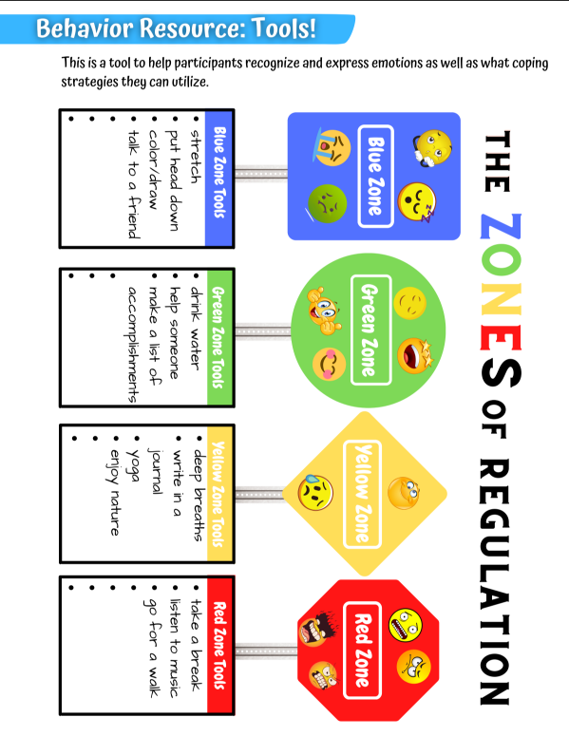
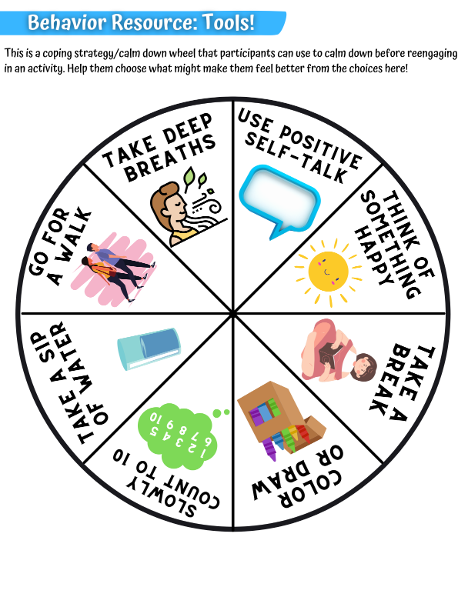
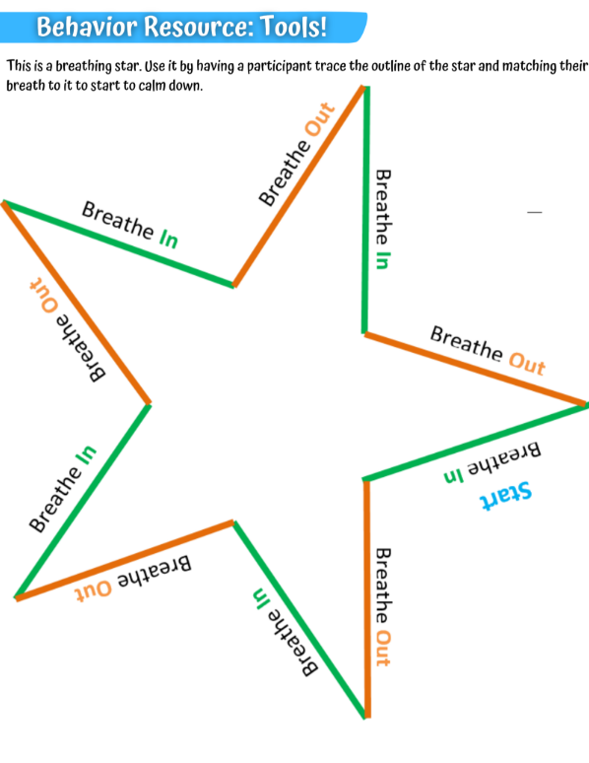
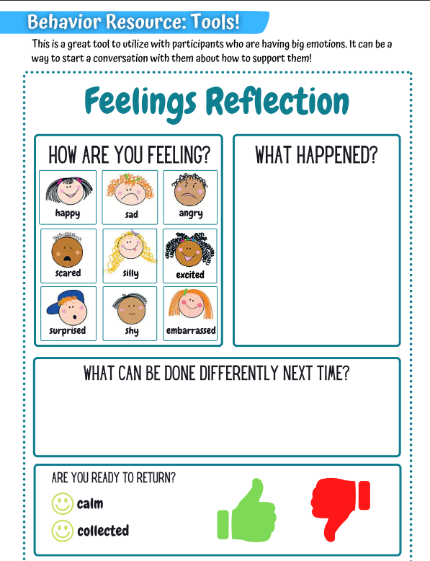

Morristown Recreation
Medication Authorization Form
Camp Directors will NOT give medication to any child until this form is completed and returned to them or the Recreation Office. Please carefully read the instructions below. If these procedures are not followed we will not be able to administer any medication to your child.
Prescribed Medication:
1. We must receive any prescribed medication in its original packaging and/or bottle with your child’s name on it.
2. It must identify the prescribing physician, the name of the medication, the dosage, and the frequency of administration.
3. All information on the bottle must also match the information you fill out on the Medication Authorization Form. Place this form and medication in a zip-lock bag and give it to the Camp Director.
Non-Prescribed Medication:
1. Must be received in original packaging and/or bottle.
2. Parents must write out the dosage and frequency of administration below and place this form with original packaging in a zip lock bag and give it to the Camp Director.

Consent to Administer Medication

The consent to Administer Medication portion of this form is good for the summer unless there is a change in medication or dosage. The Medication Log- has to be renewed each week that medication will be given while your child is at camp. You will need to provide a new Medication Log on Mondays or the first day your child will attend camp each week with the medication. Only send enough medication for one week.
Child’s Name: _________________________________________________ Gender: M/F DOB: ____/_____/_____
Prescribing Physician ___________________________________________ Office Phone # __________________________
Medication:
Medication #1 __________________________________________ Dosage _________________________________
Times to be administered: __________________________ Refrigerate: Yes____ No _____
Side Effects ________________________________________________________________________________
Stop Medication if the following reactions occur: __________________________________________________

Medication #2 __________________________________________ Dosage _________________________________
Times to be administered: __________________________ Refrigerate: Yes____ No _____
Side Effects ________________________________________________________________________________
Stop Medication if the following reactions occur: __________________________________________________

Medication #3 __________________________________________ Dosage _________________________________
Times to be administered: __________________________ Refrigerate: Yes____ No _____
Side Effects ________________________________________________________________________________
Stop Medication if the following reactions occur: __________________________________________________

Medication Log
Camper’s Name: ______________________________________ For the week of: _________________ Consent: I hereby give permission for my child to take the below listed prescription or non-prescription medication(s), as ordered, at the Stowe Parks & Recreation Summer Camp, I give permission for this medication to be administered by the Camp Director or his/her designee.
Signature of Parent/Guardian __________________________________________ Date: _________________________

This Section is to be filled out by the camp director each day that medication is administered:
Name of Medication Dosage Time Medication Given
 |  |  | MON | TUES | WED | THURS | FRI
1.
2.
3.

