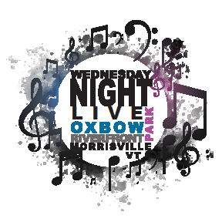

^{February 2020}
^{Dear Community:}

This will be another exciting summer of events at Oxbow Park and we’d love your support. The “Wednesday Night Live” music series is coming into its ninth year and we’ve already booked the bands for the eleven shows.
The community involvement in the music series has been spectacular. These past years many of the local nonprofits and school organizations promoted themselves and their missions, River Arts has hosted a free arts tent, but most importantly, it has been an opportunity for the community to come together in a healthy, social environment.

The park is very heavily used, as a run for dogs; with the river for them to swim in and room to play, horseshoe pits, volleyball and tetherball, soccer games and this year 2 swing sets and a climbing dome will be added to the park. Also this spring you will see the addition of the bathrooms to the park which will alleviate the portalet issues. It is a great place that many people come to enjoy a brown bag lunch, visit with friends and even enjoy some quiet time. The Oxbow Park is a prominent asset for walkers given the connectivity to the Lamoille Valley Rail Trail. With the improvements the Town and the community have made to the park over the years, it has become a destination for the local community as well as the region.

To add to the roster of great live local musicians and vendors we are asking for your support to sponsor the 11 weeks of free summer music. Your contribution will help tremendously. The sponsorship is $300.00 per year for the music series, your business name/logo will be on all of our printed literature and BOLDLY displayed on the banner at all the events. Please let me know if you would like to be part of this great music series, a fabulous community asset and a healthy venue for all. Do not hesitate to contact me with your further thoughts, ideas or concerns.

^{Many thanks,}
Tricia Follert
Community Development Coordinator
Town of Morristown, P.O. Box 748, Morrisville, VT 05661
tfollert@morristownvt.org
802.888.6669

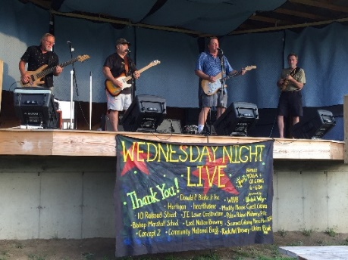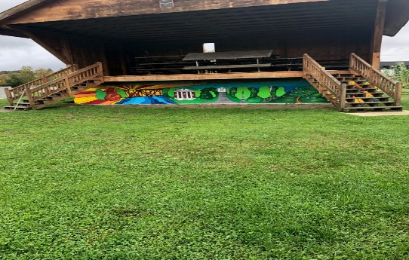
^{Live Music!!!!} Mural painted by East Meadow School

